Go Fish:
Exploring Fisheries Management

Ben Higgins, PhD Candidate and Rachel Zuercher, PhD Student, UCSC;
Satina Ciandro, Marine Biology Teacher, Watsonville High School

Field-tested with: 11th grade Marine Biology students, Watsonville High School, Watsonville, CA (May 2015)

Module Type: lab activity

Duration: 110 minute class session

Key materials:
- Laminated paper fish with life history information
- Clothespins
- Rope (at least 20 feet)
- Clip boards (optional, but useful)

Concepts: sustainable fisheries, marine protected areas, fishery dynamics, fishing regulations

Skills: Identify issues associated with fisheries (e.g. overfishing), using fish life history information to evaluate fishery regulations, using fish life history information to understand population dynamics, discuss local fisheries and their connections with the fisheries, understand variables that might influence fishery sustainability

NGSS DCI: HS-ESS3 Earth and Human Activity
NGSS Practices: 2. Developing and using models; 5. Using mathematics and computational thinking; 8. Obtaining, evaluating and communicating information
NGSS CCC: 2. Cause and Effect: Mechanism and Explanation; 4. Systems and System Models

Overview:
This project is an opportunity for students to learn:

- The “tragedy of the commons” in the context of fisheries
- The components that make up a fishery
- Some of the causes of overfishing
- How fisheries regulations work
- The benefits and costs of fisheries regulations

Navigate: Background Materials &Time Starting Point Procedures Standards Supplemental

Background for Teachers
Why this matters: More than 1/3 of people in the world rely on fish as their major source of protein, however, global fisheries face enormous challenges due to overfishing for an increasing population, habitat loss, marine pollution and climate change. Fortunately, well-designed fisheries regulations can help to solve these problems and ensure fishery sustainability into the future. Teaching students about fisheries can lead to a public that is informed regarding fisheries management, and a generation of conscious seafood consumers. Using local fisheries examples as part of this module can strengthen students’ connections with their food system and the natural world around them.
Assumed background: Students should have prior knowledge of fish (e.g. what is a fish) and very basic knowledge of fishing practices. Students should have been introduced to the concept of marine protected areas, though do not need to have a deep understanding of what they are. It will be helpful for students to have an idea of the meaning of the word “sustainability”.
Special context: Almost all high school students in the United States have eaten seafood, whether fresh or frozen, at home or at a restaurant. However, many students haven’t been guided to think critically about where seafood comes from, whether seafood is sustainable and how seafood gets from the ocean to their plate. Thinking about these concepts can help students make environmentally conscious decisions about the food that they eat. In addition, many students haven’t been introduced to the biology and statistics that are involved in fishing. Since fishing is a vocation that most students are familiar with, using the example of fisheries is a great way to introduce basic organismal biology concepts, graphing and analysis practices and critical scientific thinking and problem-solving skills.
Scaffolding supplements: The National Oceanic and Atmospheric Administration has developed and published a wide range of curricula and modules regarding fisheries and sustainable seafood. Listed below are several resources (some are specific to US West Coast fisheries).
Short Videos:

Commercial sablefish fisherman talks about his job -
https://www.youtube.com/watch?v=zkqkojzSPlE&index=13&list=PLqjRqI1v493J5KVNrGc6IkOM4agiqxRI-

Seafood Supply Chain video: how does seafood get from the ocean to your plate? -
https://www.youtube.com/watch?v=gpFCqsoDIp8

U.S. Seafood: A Success Story -
https://www.youtube.com/watch?v=-ALnClkAPA4&list=PLqjRqI1v493J5KVNrGc6IkOM4agiqxRI-&index=12

Fish Watch (a great website with information about fished species in the United States) -
http://www.fishwatch.gov

Complementary curricula about fisheries:

Voices of the Bay -
http://sanctuaries.noaa.gov/education/voicesofthebay/teachingmaterials/oceantable.html

Sustainable US Seafood: A Journal from Sea to Market -
http://www.nwfsc.noaa.gov/education/documents/NIE2_Seafood%202011_Classroom%20Guide.pdf

Sustainable U.S. Seafood: What’s Science Got to do With It? -
http://www.afsc.noaa.gov/education/Activities/sbss_module.htm

Module Description

Materials:
- Laminated paper fish with life history information written on them
- Clothespins
- Rope (at least 20 feet)
- Clip boards (optional, but useful)

Preparation:
- Read through all module materials prior to teaching the lesson
- Prepare laminated, paper fish (use local fish species if possible) and write life history information on the back of each fish (see West Coast groundfish example attached)
- Coordinate to use a large indoor or outdoor area for the fishing activity

Timeline:
- Introduction 25 min. – PowerPoint introduction to the module (with accompanying worksheet)
- Activity 60 min. – Module fishing activity
- Data analysis 20 minutes
- Wrap-up 15 minutes

Starting Point For Inquiry:
How many students have eating seafood in the last year? The last month? The last week? What type of fish did they eat? Do they know where it came from? These questions are great ways to start introducing this module. In addition, any of the videos linked above can be used as a starting point for inquiry, followed by a discussion about what students already know about fisheries (e.g. how are fish caught?) and the included PowerPoint presentation (with accompanying worksheet). Notes are included in the PowerPoint with more ideas for class discussion prompts.

Detailed Procedure:
Introduction
Instructor should use the Starting Point for Inquiry section to open the module, then use the PowerPoint presentation to guide an opening discussion. Students should each have an accompanying worksheet to follow along with the presentation. Be sure to allow time for partner, small group and class discussion. Following the introduction, the students in groups should complete the Sections 1-4 of the Go Fish! datasheet. If the class is not familiar with graphical hypotheses, these can be done on the board as a class.

Activity
This activity was done in a small grassy area outside the classroom when tested, but could be done in an open area inside. Teachers should break students into activity groups of 4-6 students. One group will be designated as NOAA (the National Oceanic and Atmospheric Administration) and one group as fisheries scientists. All other groups are fishermen that own a boat together and will be assigned a target species. Be sure that students understand that they need only to fill out the data sheet corresponding to their role (NOAA, scientist or fisherman).

Follow these steps to complete the activity.
1. Scatter fish randomly across the open area where the activity will be conducted.
2. Explain that the fishermen will have one minute to go fishing to see how much they can catch and how much money they can make. Countdown to start the minute of free-for-all fishing where one student from each fishing group grabs the laminated fish as fast as possible for their group.
3. Allow students to record data from this “tragedy of the commons” trial.
4. Re-scatter fish for the next trial.
5. Students will probably catch all or most of the fish. Explain that there aren’t enough fish left for next year, so you’re going to try this again with fishing regulations. The first regulation will be a minimum size limit. Students can no longer take fish below a certain size (in the groundfish example, 30 cm).
6. Allow students to record data from the minimum size limit trial. And prompt students to think about whether fishing was different. Next, add another regulation (while keeping the minimum size limit) until all of the following regulations have been added:
- minimum size limit – no fish under 30cm
- seasonal closure – students now only have 30 seconds to fish (simulating a fishery that is closed for part of the year)
- gear restriction – students can only pick fish up with a clothespin (simulating a fishery where only certain types of gear are allowed)
- marine protected area (MPA) – use a rope to “close” part of the fishery. Students cannot take fish from this closed area.

Data analysis
The data analysis for this module can be very easily expanded, based on the breadth and depth the teacher would like to explore. Below are three tiers of data analysis, ranging from basic to advanced. Each tier of data analysis will explain which data must be collected, and provide an example of a graphical representation of the data.

Tier 1 – Basic: Relationship between number of regulations and number of fishes caught and/or remaining in the ocean.
This is the simplest form of data collection that can be accomplished in this module. It is a relationship between a) the number of fishes collected and the number of regulations imposed during a fishing season, and b) the number of fishes remaining in the ocean and the number of regulations imposed during a fishing season. These type relationships would be best described via a scatterplots (Figure 1).

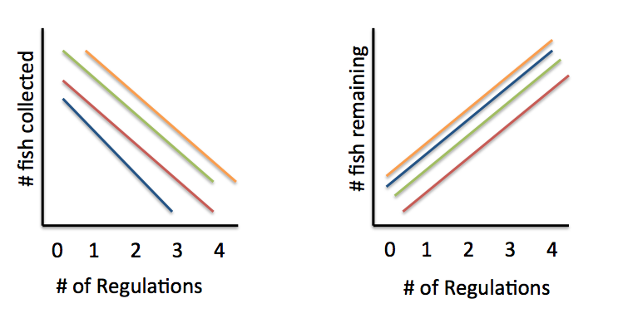
B
A

Figure 1: Hypothetical data illustrating the relationships between (A) the number of fishes collected and the number of regulations imposed and (B) the number of fishes remaining and the number of regulations imposed. Different lines represent the different fish species used in the activity. The shape and slopes of the lines may also vary because of a number of factors such as student effort, and obeying the regulations in effect.

Tier 2 - Challenging: The economic effects of regulations on fisherman catch.
This data analysis builds on the previous, but now expands the number of fishes collected to an economic factor, such as total price of the catch. Each fishing group will now be required to add up all the weights of the fishes they have caught, and then express their catch as a single dollar amount. In other words, students will be able to answer the question, “How much money did I make with the amount of fish I caught?” As the price per pound is directly correlated to the number of fishes collected, students should expect to see the same type of relationships between overall price of catch (Y axis) and the number of regulations imposed (X axis) (Figure 2). As the number of regulations increases, the number of fishes caught decreases, and therefore so does their total income.
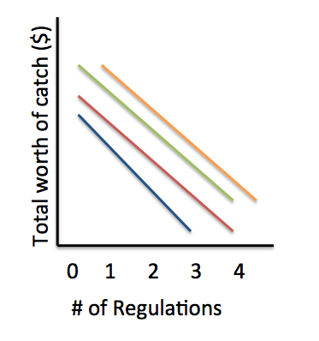
Figure 2: Relationship between total amount of catch and number of regulations imposed. Note that as the number of regulations increases, the number of fishes caught decreases, and therefore so does their total income. Different colored lines represent different fish species collected. Shape and slope of line may vary again.

Tier 3 - Advanced: Reproductive potential and fishing
This, more advanced analysis, would require students to take note of not only how many fishes they caught, but also the number of eggs that each fish could produce had they been left in the ocean. Before students graph this variable with the number of regulations imposed, it would be best if they graphed the relationship between the number of eggs produced and fish size (Figure 3). This would provide the framework for the next analysis, which would be the relationship between number of regulations and reproductive potential for future generations. Additionally, students may be able to experiment with reproductive success parameters. In other words, not every egg a fish lays becomes an adult. Therefore, different scenarios can be used to highlight this, such that another graph can be generated based on % of eggs that will ultimately become fertile adult individuals. The point here, is to highlight that there can be extreme variability in reproductive success, even within a single species from year to year because of a wide range of oceanic variables (i.e., currents, water temperatures, predation, competition, etc.).
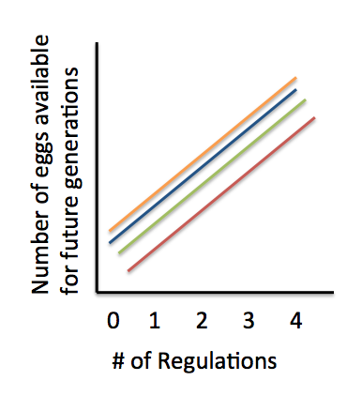
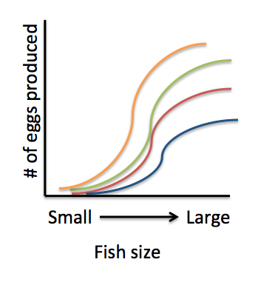

Figure 3: Relationship between fish size and the number of eggs that they can produce. These lines consider 100% success of all eggs making it to adulthood.
Figure 4: Relationship between number of regulations imposed and the number of eggs available for future generations.

Wrap-up
Use think-pair-share and classroom discussion to generate ideas about whether students think fisheries management is an easy or difficult task. Be sure students can support their opinion with evidence from the module activity. For example, a student may think that regulating a fishery is difficult because fisherman need to make money (and people need to eat) but NOAA and scientists are responsible for making sure enough fish remain in the ocean for the next year and next generation. Teachers can take this time to link the knowledge gained through this module with a simple change students can make in their daily lives. Introduce the Monterey Bay Aquarium Seafood Watch tool and talk with students about why they might want to be sure that their parents are buying sustainable seafood.

Assessment Methods:
Satisfactory understanding: Student participated in the module activity, but may have left some blanks on the worksheets. Student knows what a fishery is and can list 1-2 fisheries issues and 1-2 types of fisheries regulations. The student has trouble explaining the connection between the size of a fish, the number of eggs a fish produces, and the number of fish left for fishermen in the next year. With help from the instructor, the student can graph the relationship between variables such as the number of fishing regulations and amount of catch.

Good understanding: Student participated in the module activity and completed the worksheets. Student knows what a fishery is, can list 3-4 fisheries issues and 3-4 types of fisheries regulations. The student can explain the connection between the size of a fish, the number of eggs a fish produces, and the number of fish left for fishermen in the next year. The student can independently graph the relationship between variables such as the number of fishing regulations and amount of catch.

Excellent understanding: Student meets all criteria for “good understanding”, but can also come up with their own questions about fisheries to be answered using the life history and fishery regulation information provided. The student demonstrates an excellent understanding of the trade-offs between leaving fish in the sea and catching fish both from the perspective of a fisherman and from the perspective of the ocean ecosystem.

Possible pitfalls:
Students might not be familiar with local seafood species. However, teachers can assign students to go to the supermarket and/or talk with their parents in the week prior to the module and come to class with three local seafood species in mind.

There may be down time for some students (especially those in the fishing groups) while other students collect data following each fishing trial.

Female students might feel that the word “fisherman” doesn’t encompass female fishers. It does! It is the author’s experience that female fishers prefer to be called fishermen too.

Glossary:
Sustainability – a method of harvesting or using a resource that so that the resource is not depleted or permanently damaged.
Fishery – a fishery ground or area where fish are caught; the occupation or industry of catching or rearing fish.
Marine Protected Area (MPA) – a space in the ocean where human activities are more strictly regulated than the surrounding waters - similar to parks we have on land.
Fisheries Management – regulations that draw on fisheries science in order to find ways to protect fishery resources so sustainable exploitation is possible.

NGSS Standards Addressed
Disciplinary Core Ideas
HS-ESS3 Earth and Human Activity

Science & Engineering Practices
2. Developing and using models
5. Using mathematics and computational thinking
8. Obtaining, evaluating and communicating information

Cross Cutting Concepts
2. Cause and Effect: Mechanism and Explanation
4. Systems and System Models

Guide to supplemental materials
Several multimedia materials and documents will be used for this module.

Laminated fish example: West_coast_groundfish.pdf
Go Fish PowerPoint presentation: GoFish_presentation.ppt
Go Fish PowerPoint worksheet: GoFish_ppt_worksheet.docx
Student lab datasheet: GoFish_lab_worksheet.docx

